- \Operation\Transfer Swivel Arm\Feeding
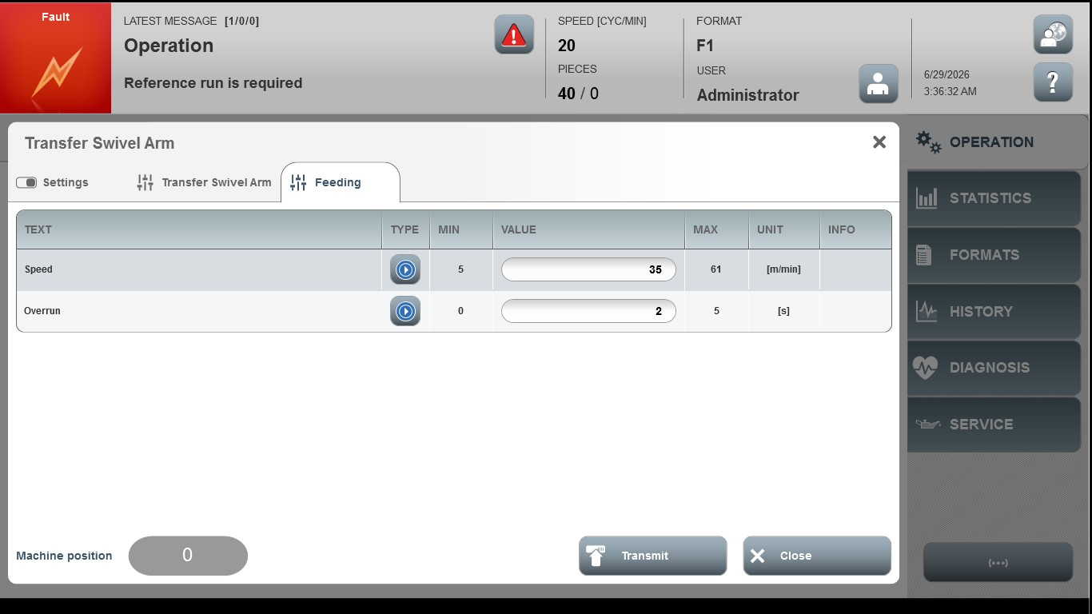
Acceptance criterion | Limits | Pass / Fail: Dev-No. | Date | Initials
Screen matches screenshot | N / A
Speed | 5 … 61
Overrun | 0 … 5

